EDM profile for Sounds
Collection of use cases

The Task Force on EDM profile for Sounds aims at creating an EDM profile for describing sounds materials. The first step in the process is the collection of use cases. These cases will allow the Task Force to scope its activities and define clear requirements that will form the basis of the EDM profile for Sounds.

The current fields for the use case templates are:

1) Title of the use case(s)

Ethnomusicological records (published or unpublished - all types of carriers)

2) Owner's case name and name of the represented institution

CNRS - CREM team

Use case(s):
3) Provide a general description of your use case(s). You can also add to your use case(s) images, diagrams if needed.
A use should contain information on:
-what is the type of sound objects you provide Europeana (vinyle, recording, music sheet….)
-Are these objects composed of different elements? If yes, what is the type of the relationship between an object and its different components or between the components themselves?
-Do the objects have digital representations? And if yes, of what type (same recording in different formats, video, images…)?

Example from the report of the Task Force on Hierarchical Objects http://pro.europeana.eu/web/network/europeana-tech/-/wiki/Main/Taskforce+on+hierarchical+objects written by Rodolphe Bailly, Cité de la Musique.
At the Cité de la musique, a concert recording is documented as a hierarchy of records.
The first, top level record describes the "concert". It contains general information about the recording of the concert itself, such as title, date, location and the most important performers and composers. The other records describe the "constituents" of the concert, i.e. the musical works performed during the concert. Each of these constituent, situated at a lower level of the hierarchy, contains detailed information about the performed musical works (for instance the complete list of performers). If needed, each of the performed musical work record may also have constituent records, such as specific parts in a symphony.
This concert recording can be represented as follow:
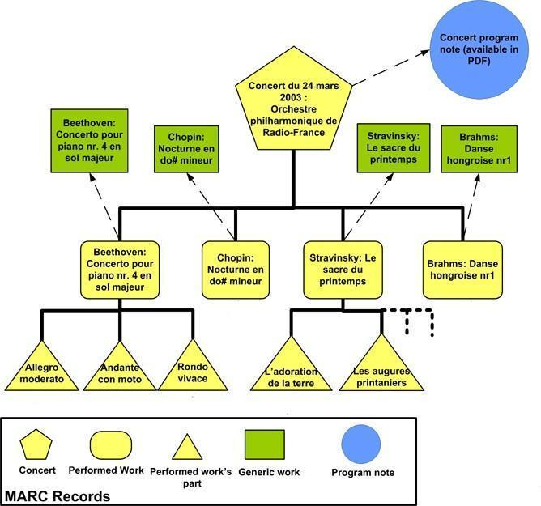

The audio archives of the CREM includes commercial and unpublished records of traditional music from around the world, oral traditions and spoken words in numerous languages, recorded on all types of carriers (wax cylinders, 78 rpm, vinyls, magnetic tapes, audio CDs, born digital records).
The database is organized on 4 hierarchical levels of description : Fonds > Corpus > Collection > Item. The main level of description is “Collection”, providing general informations about a collection of items. For example, a collection can be a commercial disc or a set of records done during a fieldwork by a researcher (in the code, CNRSMH_E indicates published records, and CNRSMH_I for unpublished records). The item level give access to the audio file (preserved in wav with MP3 streaming). Collections can be included in corpus and fonds, 2 upper and optional levels to contextualize the collections.

Data sample illustrating the use case
4) Each use case should be illustrated by (a) data sample(s).
Upload your data sample(s) at https://drive.google.com/folderview?id=0B4N3jJ2PToabWU1scDVFZGVKVEU&usp=sharing and indicate the name of the file(s) in this questionnaire for reference.

CNRS_CREM_Usecase20140513.xls (to be joined on the 13rd of may)

5) What metadata format is used in the samples(s)?

Internal and non standardized model with a partial export in DC qualified

6) Describe how you use this metadata format to support the described use case(s) (can include details on specific metadata elements, data quality aspects…)

This format is currently under revision (model and export in DC) as it doesnt suit our specific needs to describe and manage the archives. A revision plan will be available in few weeks. Work in progress until september/october 2014.

Vocabularies
7) Are you using specific vocabularies(e.g. thesauri) to describe information such as subjects, genres in your metadata?
If not go to question 11.

Geographic : GeoEthno (http://www.mae.u-paris10.fr/dbtw-wpd/bibliotheque/g/MON.html) linked with Geonames (on state level for geolocalization)
Languages : ISO 639
Population : in-house developed list (to be improved)
Keywords (thematic) : in-house developed list (to be improved)
Medium format : in-house developed list (to be improved)
Musical Instruments (generic terms) : in-house developed vocabulary, based on Hornbostel and Sachs classification (to be improved and harmonized with RAMEAU and MIMO)
Musical Instruments (vernacular terms) : in-house developed list (to be improved and harmonized with the Grove dictionary and RAMEAU)
Voice (generic terms) : in-house developed list (to be improved)
Musical style (generic terms) : in-house developed list (to be improved)
Musical style (vernacular terms) : in-house developed list (to be improved)

8) If yes, how are you using them? In which metadata fields?

dedicated fields of the database for each vocabulary in the internal model, with partial export in dc terms (only 3 vocabularies are currently exported : keywords = subject, geographic = coverage-spatial, format = format-medium)

9) What is the language coverage of these thesauri/vocabularies?

french, english (for languages list only)

10) How are the thesauri/vocabularies represented (e.g. a database, an XML file, SKOS, etc.)? If possible provide an example of (a part) of the thesauri/vocabularies you use (e.g. a fragment of XML, etc.).
Copy and paste an example in the questionnaire or upload your vocabulary sample at https://drive.google.com/folderview?id=0B4N3jJ2PToabWU1scDVFZGVKVEU&usp=sharing and indicate the name of the file(s).

Closed lists in alphabetical order, that can be exported in xls or xml files.

Enrichment
11) If you are not using thesauri/vocabularies, would you like to see your metadata enriched with references to thesauri/vocabularies?

12) Which metadata fields would you like to see enriched?

Terms to refine :
Subject : for musical instruments or voice ; for recording context (field research, studio, concert, …)
Contributor : for record collector, for performers
Type/Status of document : for published/unpublished records distinction
Rights or Access : ethic aspects and restrictions

